SETTING UP THE CSI (Comité de Suivi Individuel)
This form must be submitted to the speciality head
no later than 1st March 2024

PhD student
Name and surname of the PhD student: | Email: | Phone number:
Thesis speciality at EEATS:

PhD student’s host research unit:  Academic laboratories or Department/Service and Laboratory at the CEA | Explicit name:
PhD student’s research team: | Explanatory title:
Starting date of thesis: | If different, start date of doctoral contract:
Title of thesis:
(as declared in training agreement)
Keywords (as declared in the individual training agreement):

Supervision
 | Functions  MCF, Pr, DR, Ing., others | HDR | Affiliation: Institution/Laboratory/team | E-mail / phone number
Name of director of thesis |  | Yes
Name of co-director, if any |  | Yes
Co-supervisor 1

Co-supervisor 2

Speciality heads
AP « Automatique – Productique »  Sylvie Charbonnier:  sylvie.charbonnier@grenoble-inp.fr  Phone: 04.76.82.64.15 | GE « Génie Electrique »  Laurent Giraud:  laurent.gerbaud@g2elab.grenoble-inp.fr  Phone: 04.76.82.62.94 | OR « Optique Radiofréquence »  Anne Vilcot:  anne.vilcot@grenoble-inp.fr  Phone: 04 56 52 95 42 | SIPT « Signal Image Parole Télécom »  Steeve ZOZOR:  steeve.zozor@gipsa-lab.grenoble-inp.fr  Phone: 04 76 82 71 04
NENT « Nano-Electronique et Nano-Technologies » : Doctoral students from research units at CEA Leti (excluding DSYS and DSCIN), CEA Liten, LTM and LMGP  Jumana BOUSSEY: jumana.boussey@univ-grenoble-alpes.fr  Phone: 04.38.78.11.97 |  | NENT « Nano-Electronique et Nano-Technologies » : Doctoral students from other research units in the NENT speciality, including those affiliated with CEA/Leti/DSYS and CEA/LIST/DSCIN  Olivier ROSSETTO : rossetto@lpsc.in2p3.fr  Phone: 04.76.28.41.11

Proposal for the composition of the CSI

In consultation with your thesis director, please propose the two members of your CSI, taking care to comply with the following criteria:
- None of the members belong to your team or to the teams of the people involved in your supervision (director, co-director and any co-supervisors, including those from co-tutoring partner institutions).
- Both members hold a doctorate and at least one member holds an HDR.
- At least one member is from outside the research unit where you are carrying out your thesis, and as far as possible, from outside the institution where you are registered (UGA or USMB).
- At least one member is a specialist in the discipline or related to the field of the thesis.
- At least one member is a non-specialist, outside the field of the thesis.

Please enter this composition on your ADUM profile

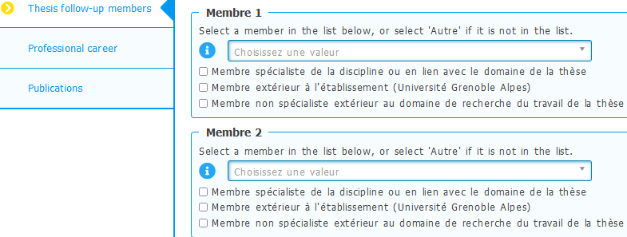
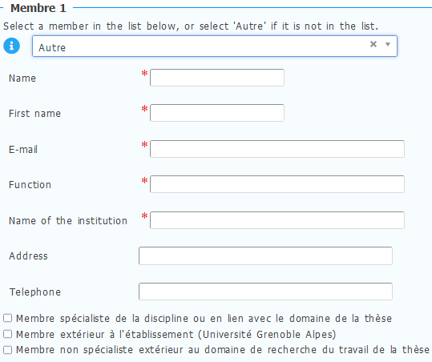

And report it on the following table to your speciality head:

Validation of the composition of the CSI

 |  | To be completed by the PhD student |  |  |  |  |  | For speciality head only
 |  | Name | Surname | Email / Phone number | Function  MCF, Pr, DR, Ing., .. | HDR | Affiliation  Institution/research unit/team | Outside the team | Outside the research unit | Discipline specialist | Non-specialist
Member 1
Member 2

PhD student: | Director of thesis: | Approval from the doctoral school:  Speciality head
Date and signature | Date and signature | Date and signature

